**Student Questions**

Learn about the internals of a standard PC case by examining physical samples and selecting and labeling images found on-line. Gain deeper knowledge by researching and reporting on specific components.

PC Tower Case

E

1. Find one (or more) images that clearly show the internals of a PC Tower Case.   
   (i.e. Google images using keywords ”)  
   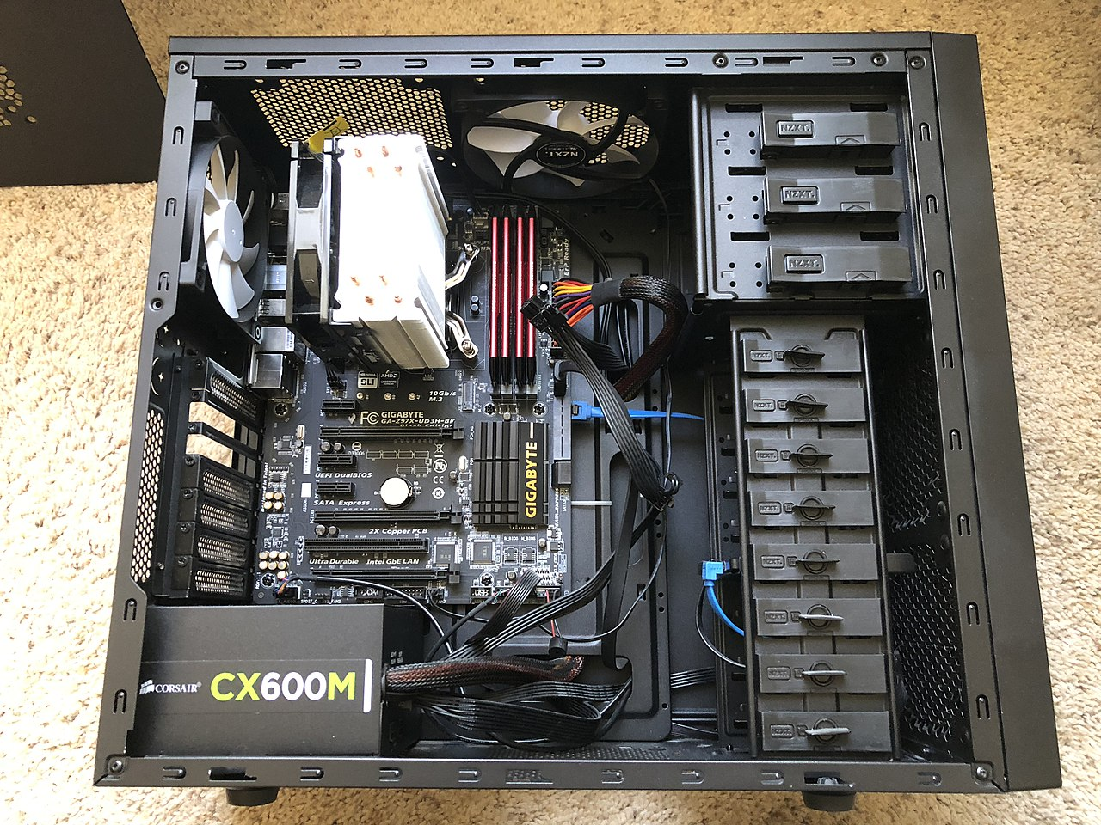

E

C

D

C

A

B

I

1. Clearly label the following components (using arrows) on your image of the PC case internals:
   1. Motherboard

H

* 1. Power Supply
  2. Hard Disk Drive
  3. Optical Disk Drive (e.g.DVD)
  4. USB Expansion Ports
  5. **Monitor Port**
  6. **Audio Ports** 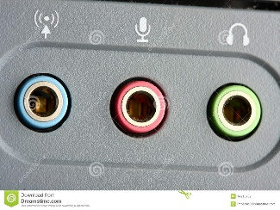
  7. Ethernet Port
  8. Cooling Fan

1. Research more in-depth about “Hard Disk Drives”. Make notes on the following:
   1. What different versions are currently available (speed and capacity)

There are two main hard disk drives models, which are 3.5-inch for desktop computers and 2.5 inch, which are for laptops.

* 1. How the capacity of the component has changed since the 1980’s  
     Throughout, the 1980s, the capacity of the component has changed in price and in size. The price used to be over $1500 whereas now the price is near the $50 value. Also, before, the HDD could only hold 5 MB, and now it holds one whole TB.

PC Motherboard

1. Find one (or more) images that clearly show the layout of a PC Motherboard.   
   (i.e. Google images using keywords “PC Motherboard”)  
   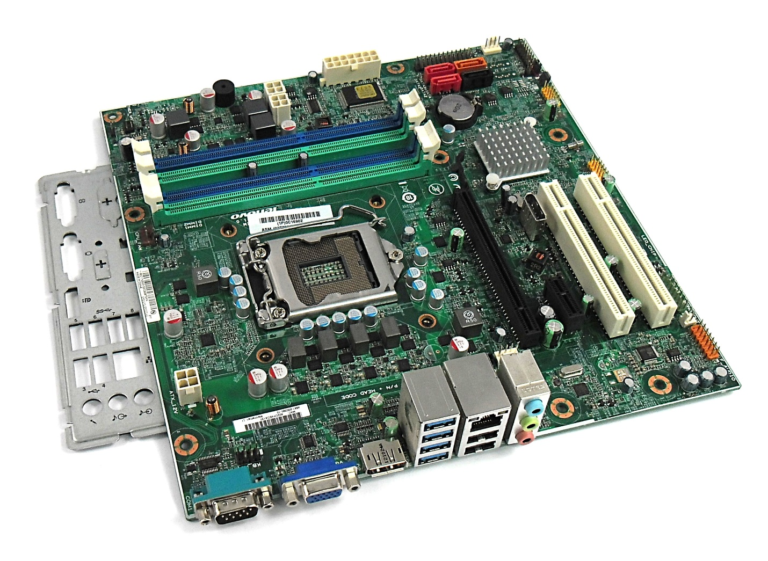

B

A

F

1. Clearly label the following components (using arrows) on your image of the PC motherboard:
   1. CPU (and fan)
   2. RAM Memory
   3. Disk Drive Interface (IDE or SATA) - NOT ON BOARD

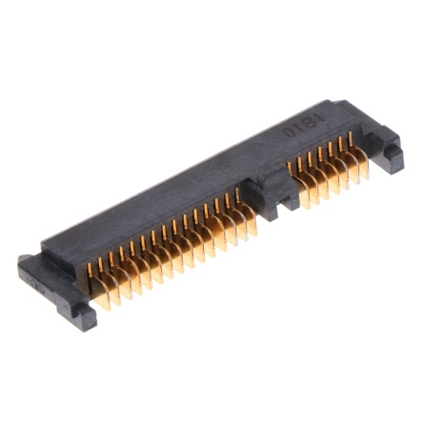

* 1. GPU Graphics Processor (either on-board or Graphics Card) - NOT ON BOARD

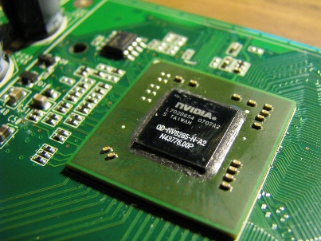

* 1. Sound Processor (either on-board or Sound Card) - NOT ON BOARD

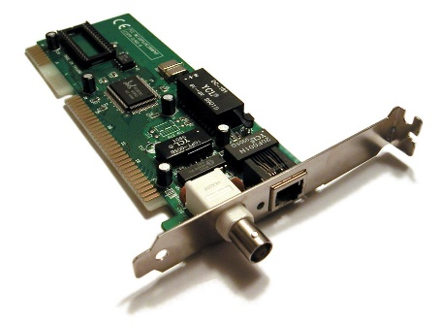

* 1. Wi-Fi / Ethernet Network Interface (either on-board or Graphics Card)

1. Research more in-depth about “CPU Processor Chip”. Make notes on the following:
2. What different versions are currently available (speed and capacity)

Ever since 2009, there has been seven different CPU processing chips including Intel Pentium, Intel Core, Intel 2, Intel Core i3, Intel Core i5, Intel Core 17, Intel Core 17, Intel Core i1, Intel i9, Intel Core i9 (extreme)

1. How the speed of the component has changed since the 1980’s  
   Before, in the 1970s, the processing chip bus speed was 400 MHz, 533 MHz. Nowadays, the processing chips bus speed is 1066 MHz, 1600 MHz.

Peripheral Devices

1. Find one (or more) images that clearly show the layout of the back of a typical PC tower case.   
   (i.e. Google images using keywords “Back Of PC Tower”)

A

D

C

B

F

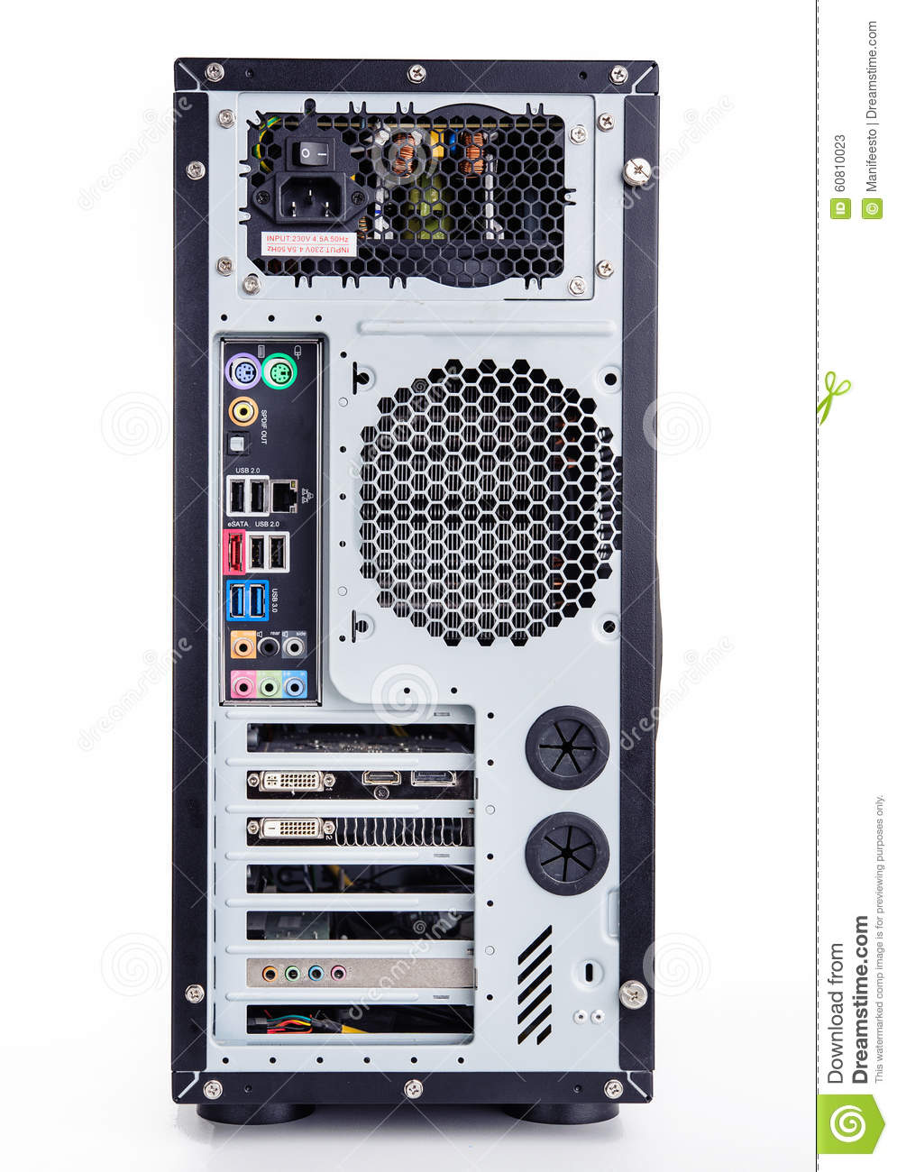

E

1. Clearly label the following components (using arrows) on your image of the back of a typical PC tower case:
   1. Power cord and power switch
   2. Monitor Interface (VGA or DVI or HDMI)
   3. Mouse Interface (USB or PS/2)
   4. Keyboard Interface (USB or PS/2)
   5. USB Ports
   6. Audio Inputs / Outputs
   7. Ethernet Interface

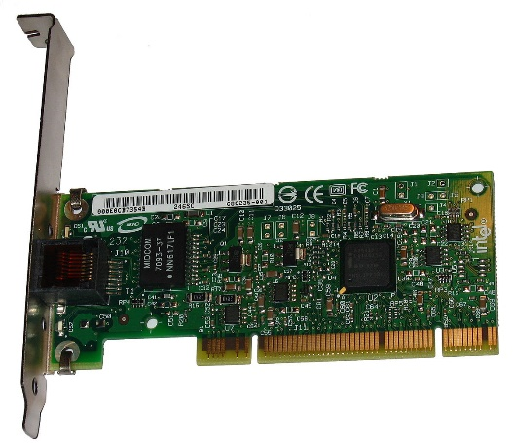

1. Research more in-depth about “External Portable Storage”. Make notes on the following:
2. Floppy Disks

A [floppy disk](https://en.wikipedia.org/wiki/Floppy_disk" \o "Floppy disk) is a disk storage medium composed of a disk of thin and flexible [magnetic storage](https://en.wikipedia.org/wiki/Magnetic_storage" \o "Magnetic storage) medium encased in a rectangular plastic carrier.

1. CD-ROM / DVD / Recordable CD/DVD

DVD (an abbreviation of digital versatile disc) is a [digital](https://en.wikipedia.org/wiki/Digital_media" \o "Digital media) [optical disc](https://en.wikipedia.org/wiki/Optical_disc" \o "Optical disc) [storage](https://en.wikipedia.org/wiki/Data_storage_device" \o "Data storage device) format invented and developed in 1995.

1. USB Memory Drives

A USB flash driveis a [data storage device](https://en.wikipedia.org/wiki/Data_storage_device" \o "Data storage device) that includes [flash memory](https://en.wikipedia.org/wiki/Flash_memory" \o "Flash memory) with an integrated [USB](https://en.wikipedia.org/wiki/USB" \o "USB) interface.

1. Compact Flash Memory

CompactFlash (CF) is a [flash memory](https://en.wikipedia.org/wiki/Flash_memory" \o "Flash memory) [mass storage device](https://en.wikipedia.org/wiki/Mass_storage_device" \o "Mass storage device) used mainly in portable electronic devices.

1. Cloud Based Storage

Cloud storage is a model of [computer data storage](https://en.wikipedia.org/wiki/Computer_data_storage" \o "Computer data storage) in which the [digital data](https://en.wikipedia.org/wiki/Digital_data" \o "Digital data) is stored in logical [pools](https://en.wikipedia.org/wiki/Pool_(computer_science)" \o "Pool (computer science)). 